**Step 1: Set Up Your Redshift Cluster**

If you don't have a Redshift cluster set up already, you’ll need to:

1. **Create a Redshift Cluster**: You can use the AWS Management Console to launch a Redshift cluster.
2. **Set up a Security Group**: Make sure the Redshift cluster is accessible from your IP address (you may need to modify the Security Group settings to allow inbound access on port 5439).
3. **Set up IAM Role for S3 Access**: Attach an IAM role with permissions to access S3 if you're loading data from there.
4. **Create Redshift Database and Tables**: Once the cluster is ready, create a database and tables in Redshift.

**Step 2: Load Data into Redshift**

You can load data into Redshift using several methods, but one of the most common approaches is using **Amazon S3** and the **COPY command** in Redshift.

**Loading Data from S3 to Redshift**

Let’s assume you have a CSV file stored in an S3 bucket and want to load that data into Redshift. The process involves:

1. **Preparing the Data File**: Ensure your data is stored in a format Redshift can read (CSV, TSV, Parquet, etc.)

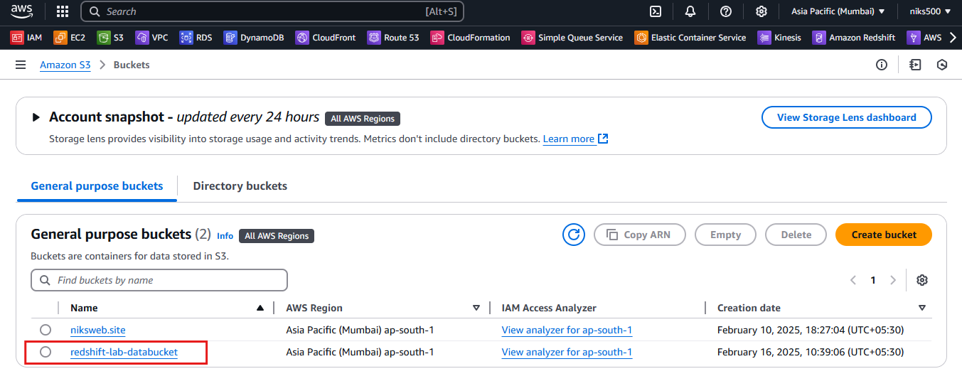

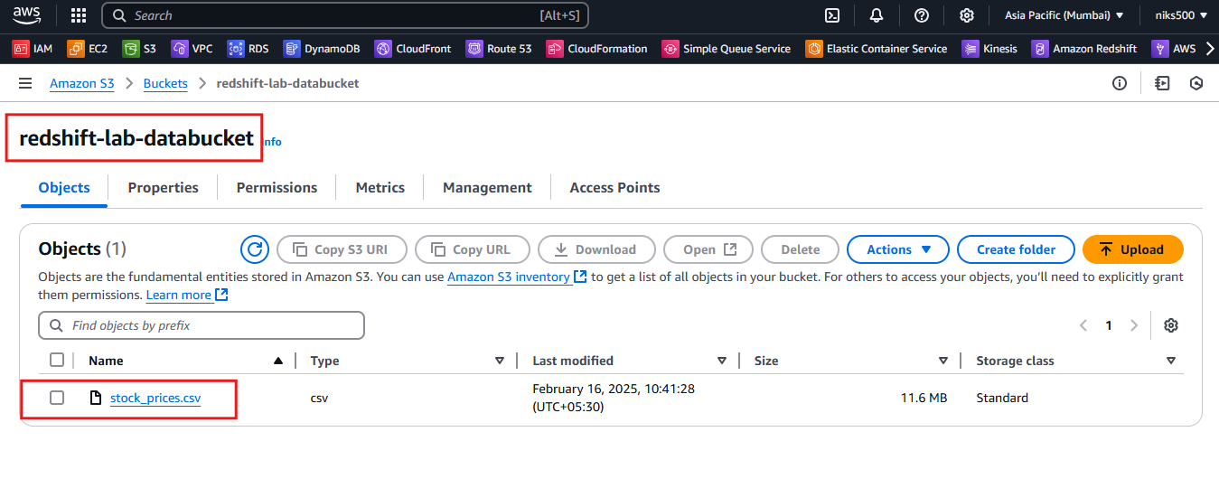

1. **Grant Permissions to S3**: Your Redshift cluster should have permission to access the S3 bucket (through an IAM role).

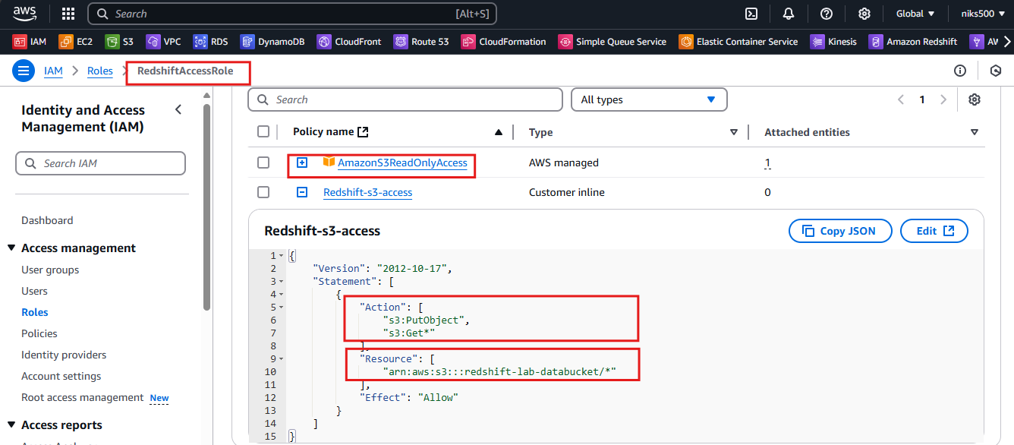

1. Using the DBeaver prompt, enter the following query to create a new table named **stocksummary**

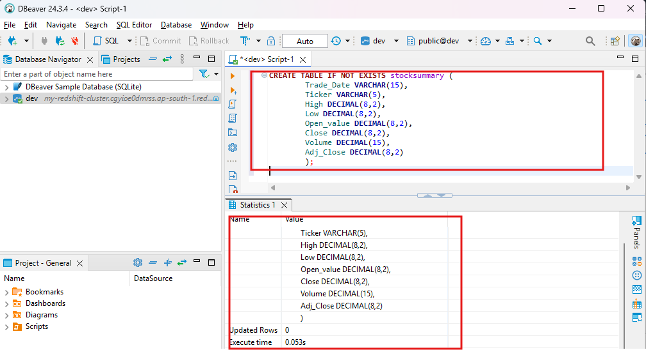

1. **Use the COPY Command**: The COPY command is used to load data from S3 into Redshift.

Example:

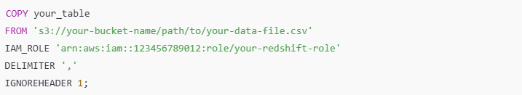

* **your_table**: The target table in your Redshift database.
* **s3://your-bucket-name/path/to/your-data-file.csv**: The S3 URI where the CSV file is stored.
* **IAM_ROLE**: The ARN of the IAM role that allows access to the S3 bucket.
* **DELIMITER**: The delimiter used in the file (e.g., , for CSV).
* **IGNOREHEADER**: Optional, used to ignore the header row if your file contains column headers.

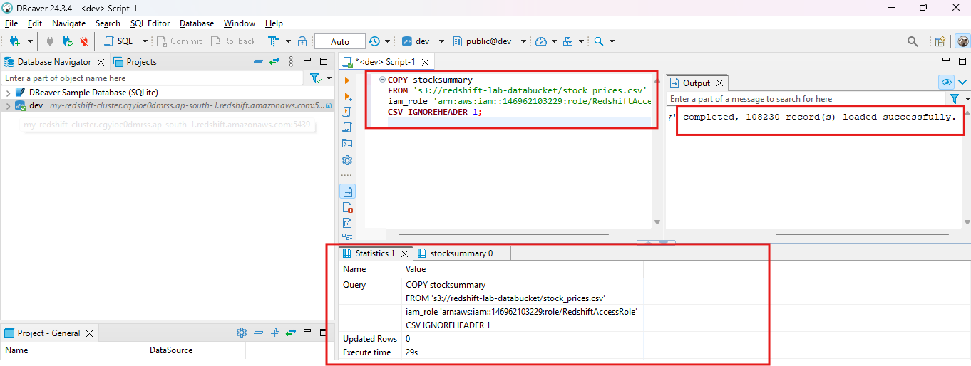

**Step 3: Query Data in Redshift**

Once you have the data loaded into Redshift, you can run SQL queries to retrieve and analyze the data.

**Basic SQL Queries**



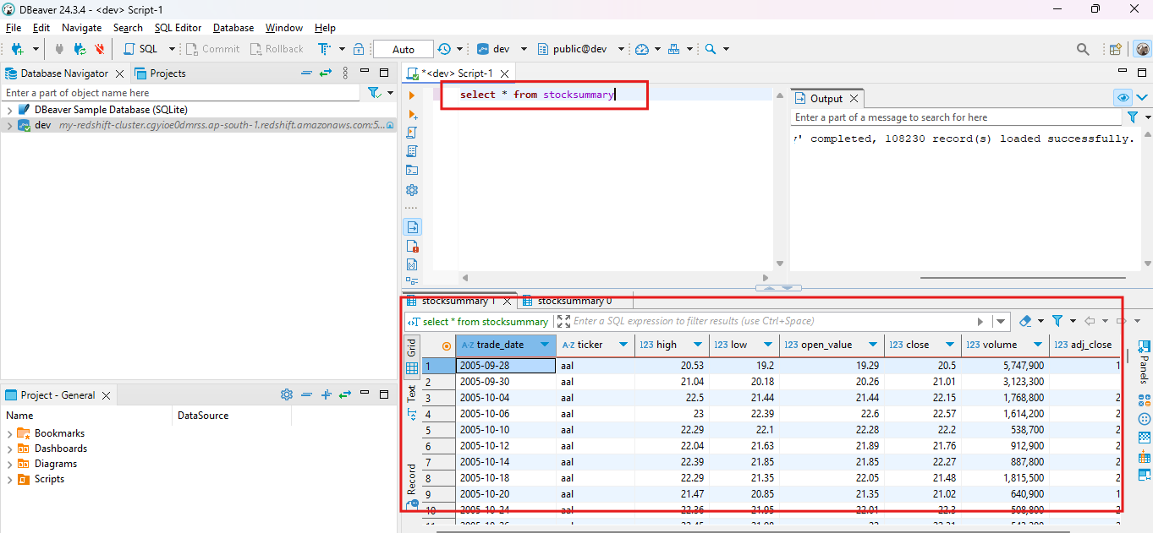

Using the prompt, enter the following query to query the **stocksummary** table for the stocks that were traded on January 3, 2020:



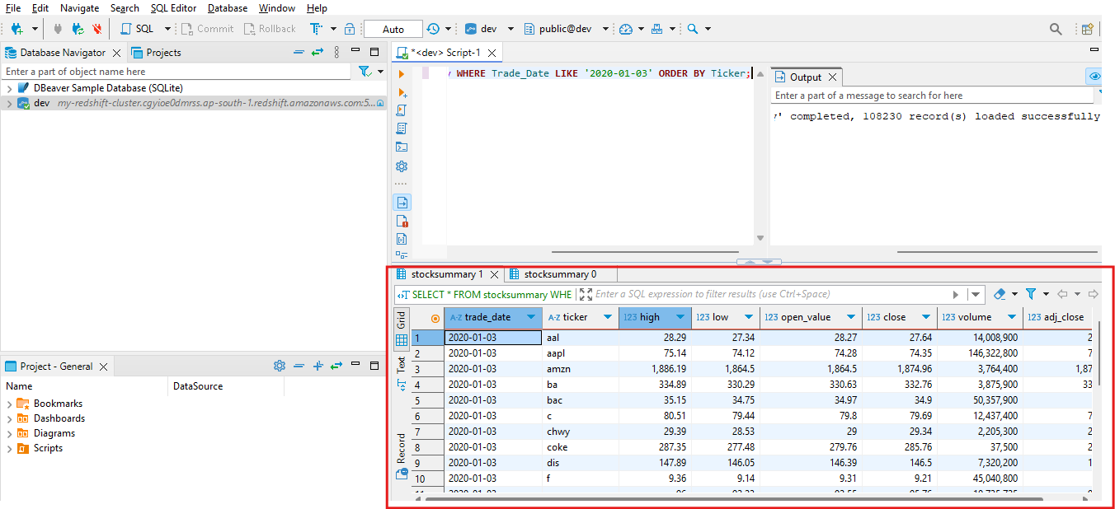

Using the prompt, enter the following query to find the all-time high stock price for each company:

